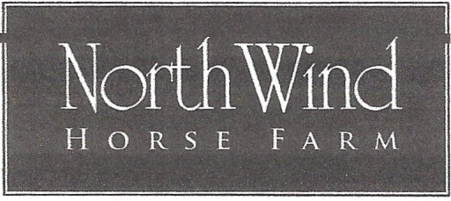
2496 Bruynswick Road, Wallkill NY 12589
HudsonValleyDressageShows.com
North Wind Horse Farm DRESSAGE SHOW ENTRY FORM
Rider’s Name: __________________________________ USDF #:____________________________

Address: _____________________________________________________________________________

Email: _____________________________________ Phone: ____ - ___________________________
(required)
Rider Date of Birth _______________________ Junior/ Senior

Horse’s Name: _______________________ DOB:________ Breed:_____________ USDF #:________

Owner’s Name: _________________________________ USDF #: ____________________________
Owner’s Address:______________________________________________Email___________________

Cost Per Class: $35.00
Office Fee: $10.00

Class # | Class Name |  | Total
 |  |  | $________
 |  |  | $________
 |  |  | $_________
 |  |  | $________
 |  | Office Fee | $10.00
 |  | Total
Entries Must Be Accompanied With Payment To: North Wind Horse Farm
2496Bruynswick Rd., Wallkill, NY 12589 or emailed to: nwhf@frontiernet.net
(payment must be received within five (5) days of receipt of email entry)
To avoid late fee Entries must be received by closing date. “USDF Regional Schooling Show Awards Program Participating Competition”

North Wind Horse Farm
Release Form
1 form per Participant – Rider

I acknowledge the inherent risks associated with horseback riding and I am participating at my own risk. I hereby assume this risk and further do release and hold harmless and indemnify North Wind Horse Farm and its owners, organizers, judges, and officials, their officers, agents, employees and volunteers, the host of this event or horse show and the owners of any property on which the event or show is being held, from all liability for negligence or any responsibility for accidents, damage, injury or illness to myself, owners, lessee, trainers, handlers, riders, grooms, employees, attendants, spectators, or any other person or property whatsoever including the horse or horses which I will compete at this event or show.
By entering and signing all forms I agree to the above statement.
If I am a parent or guardian of a junior exhibitor, I consent to the minor’s participation and agree to the above statement.

______________________ _________________________ ____________________
Rider’s Signature date Parent or Guardian signature date Owner’s signature date

______________________ _________________________ _____________________
Print Name Print Name Print Name

