North Wind Horse Farm  2496 Bruynswick Road  Wallkill, NY 12589 |  | 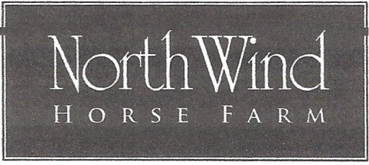  Sunday, September 17, 2023 |  |  | Rosemary Budney  (845) 744-5584  nwhf@frontiernet.net  northwindhorsefarm.com
Judge:  Nicole Ivins L |  | “USDF Regional Schooling Show Awards Program Participating Competition” |  |  |  | Opening Date: Aug14th  Closing Date: Sept 11 th
INTRO  1. Intro Test A  2. Intro Test B*  3. Intro Test C  TRAINING LEVEL  4. Training Level Test 1  5. Training Level Test 2  6. Training Level Test 3*  FIRST LEVEL  7. First Level Test 1  8 First Level Test 2  9. First Level Test 3*  SECOND LEVEL  10. Second Level Test 1  11. Second Level Test 2  12. Second Level Test 3* |  |  |  | 13. USEF Test of Choice  14. USEA Test of Choice  15. Western Dressage (WDAA test of choice)  16. Western Basic 4*  17. Prix Caprilli 1  18. Prix Caprilli 2  19. If time permits Equitation (post entry $15.00  *Qualifing classes for the HVDS Championship Show are the highest test of the level except Intro level (test B qualifys) Two scores of 60% or higher at two different shows  Scores will be submitted to the USDF for the Regional Schooling Show Awards Program. Riders must submit a $35.00 nominating fee directly to the USDF to enroll in the awards program.  Management reserves the right to cancel, split or combine  classes as necessary.
Entries:
Fees | Class Fee: $35.00 per class / *Championship Qualifying Classes $50.00  Office Fee: $10.00 for each horse/rider combination  Late Entry Fee: $10.00 per class / Returned Check Fee: $50.00
Awards | Ribbons awarded 1st through 6th place / Junior & Adult High Point awards.
Refunds | Refunds given prior to closing date: September 11th (less office fee).
Arenas | Tests will be ridden in Outdoor sand arena/ Indoor arena will be used for warm-up.
Stalls  Health  Payment  Times | Stalls are not available.  Equine proof of vaccination of EIV, EHV 1 and EHV 4 and Negative Coggins required.  Make checks payable to North Wind Horse Farm. Venmo @Rosemary-Budney add $5.00  Mail entry with payment to: North Wind Horse Farm/ 2496 Bruynswick Road/ Wallkill, New York 12589.  Times will be posted on North Wind Horse Farm.com or facebook  PLEASE PICK-UP AFTER YOUR HORSE * DOGS ARE NOT ALLOWED

NORTH WIND HORSE FARM

RELEASE

____ I acknowledge the inherent risks associated with horseback riding and I am participating at my own risk. I hereby assume this risk and further do release and hold harmless and indemnify North Wind Horse Farm and it’s owners, organizers, judges, and officials, their officers, agents, employees and volunteers, the host of this event or horse show and the owners of any property on which the event or show is being held, from all liability for negligence or any responsibility for accidents, damage, injury or illness to myself, owners, lessee, trainers, handlers, riders, grooms, employees, attendants, spectators, or any other person or property whatsoever including the horse or horses which I will compete at this event or show.

By entering and signing all forms I agree to the above statement.
If I am a parent or guardian of a junior exhibitor, I consent to the minor’s participation and agree to the above statement.

__________________ ________________ __________________
Rider’s signature Parent or Guardian signature Owner’s signature

___________________________ _______________________ __________________________
Print Name Print Name Print Name

